**MSBA 250 — Applied Business Analytics**

**University of the Pacific**

**Spring 2024**

**Assignment 2**

**Due: Saturday February 24, 2024**

**Instructions:**

This problem set has 2 questions. The full credit is 20.

**Problem 1 (10 points):**

Please use the EXCEL file of “Purchase Survey Data”

Please use EXCEL to:

1. Create summary statistics for delivery speed (5 points).

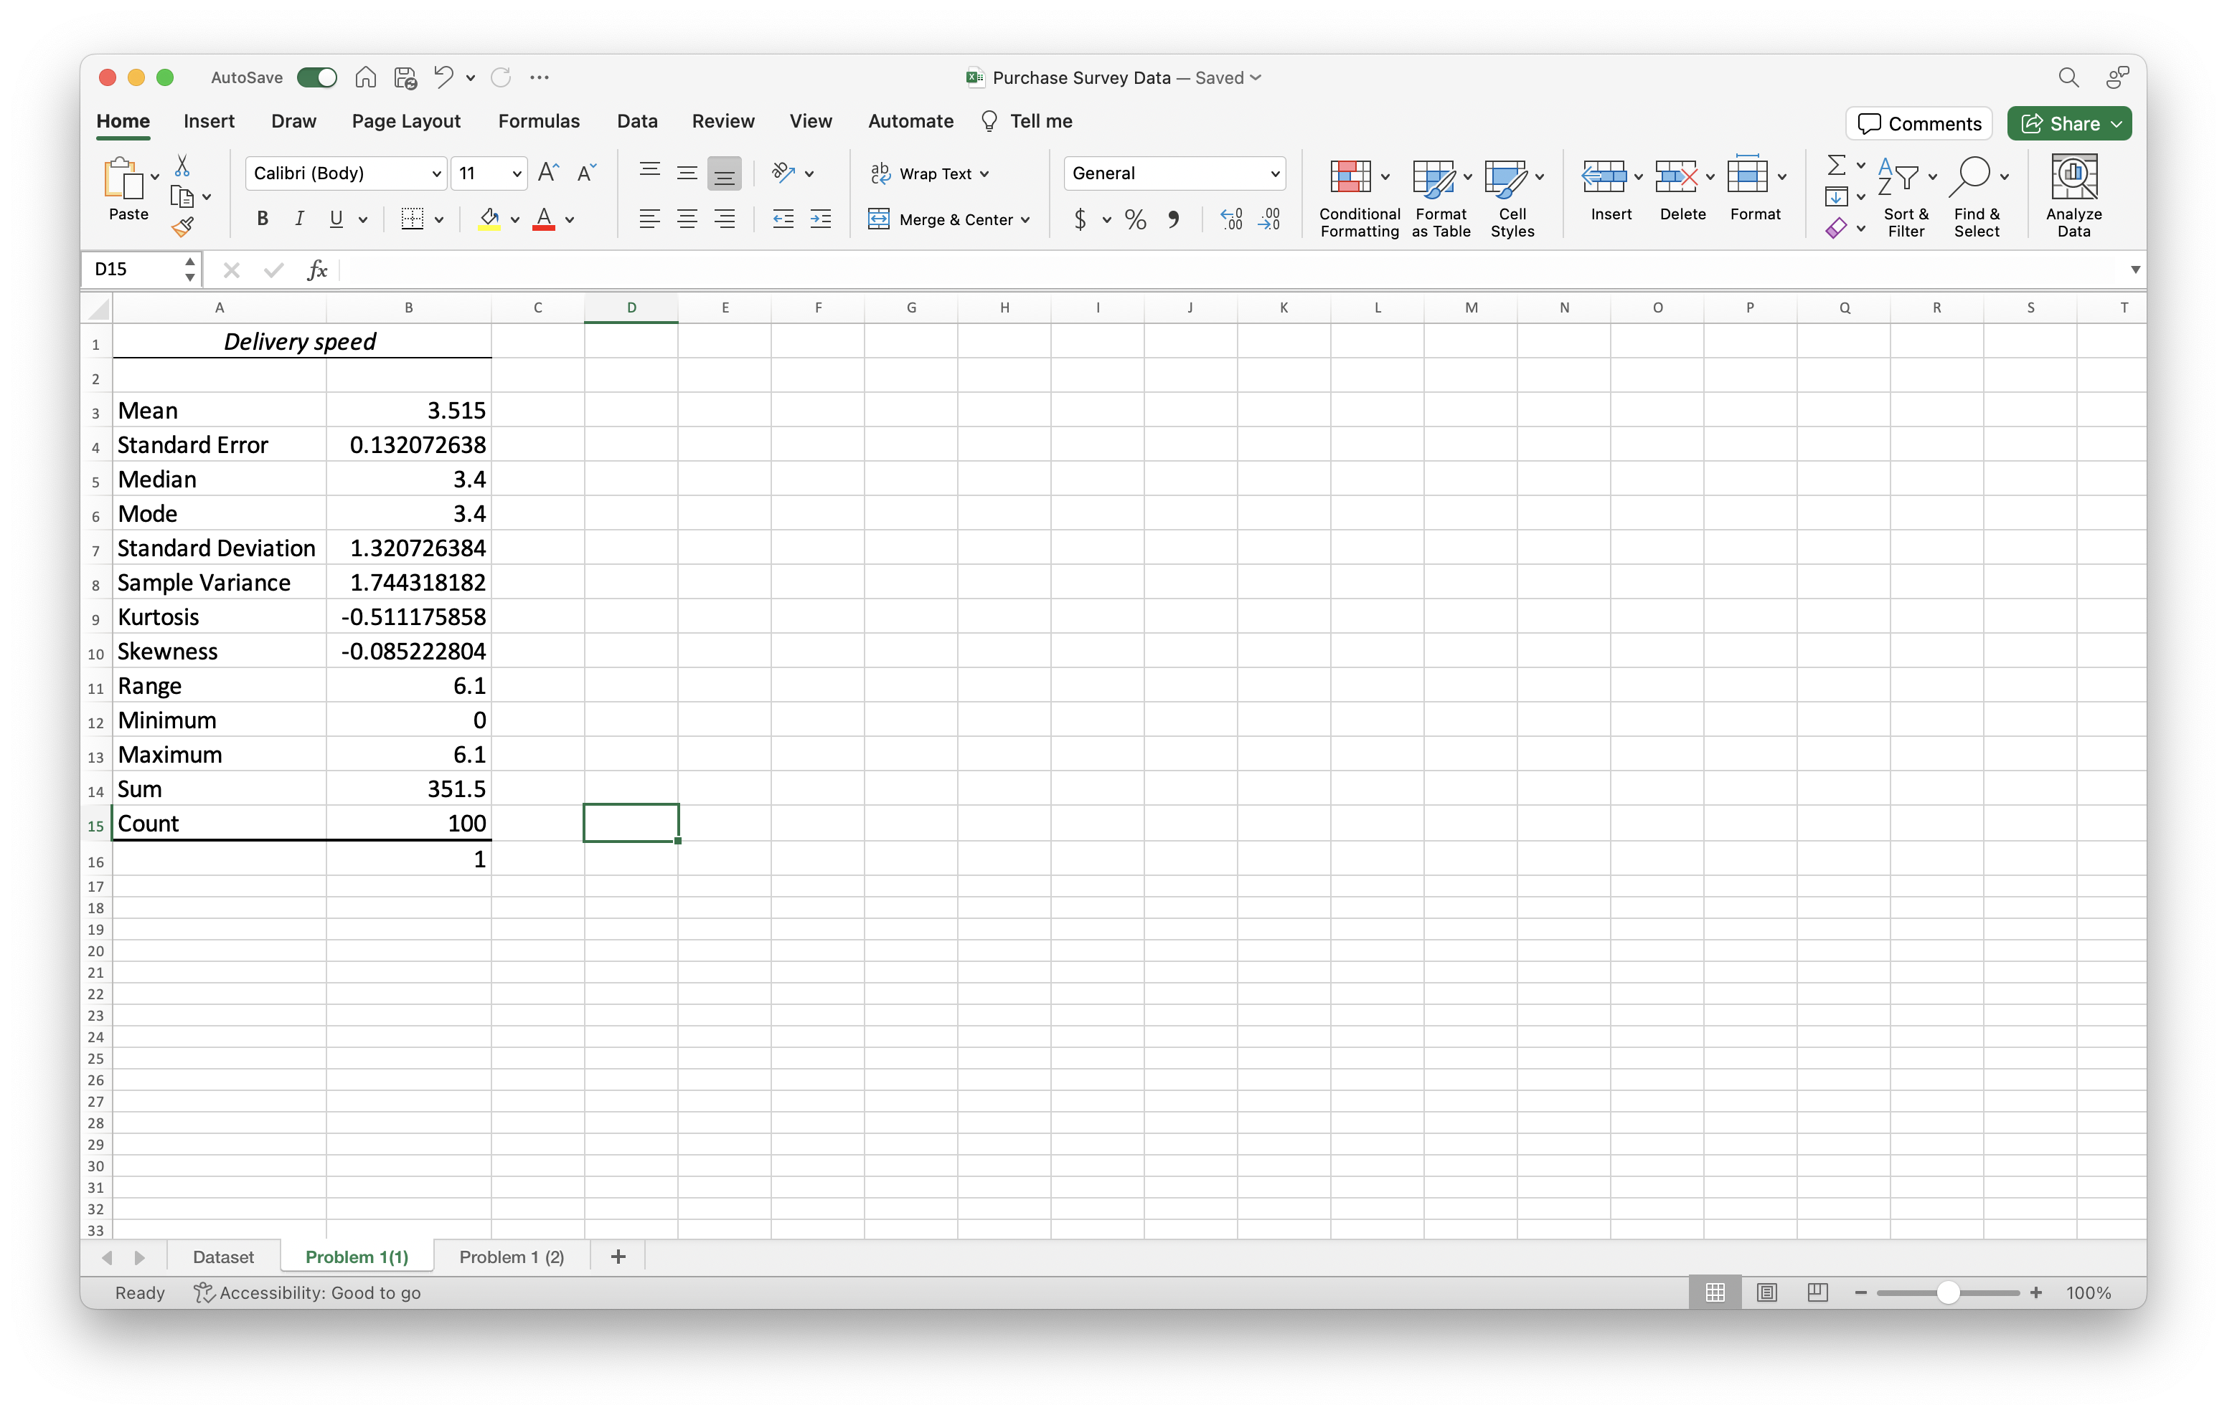

1. Create a correlation Table for all variables (5 points).

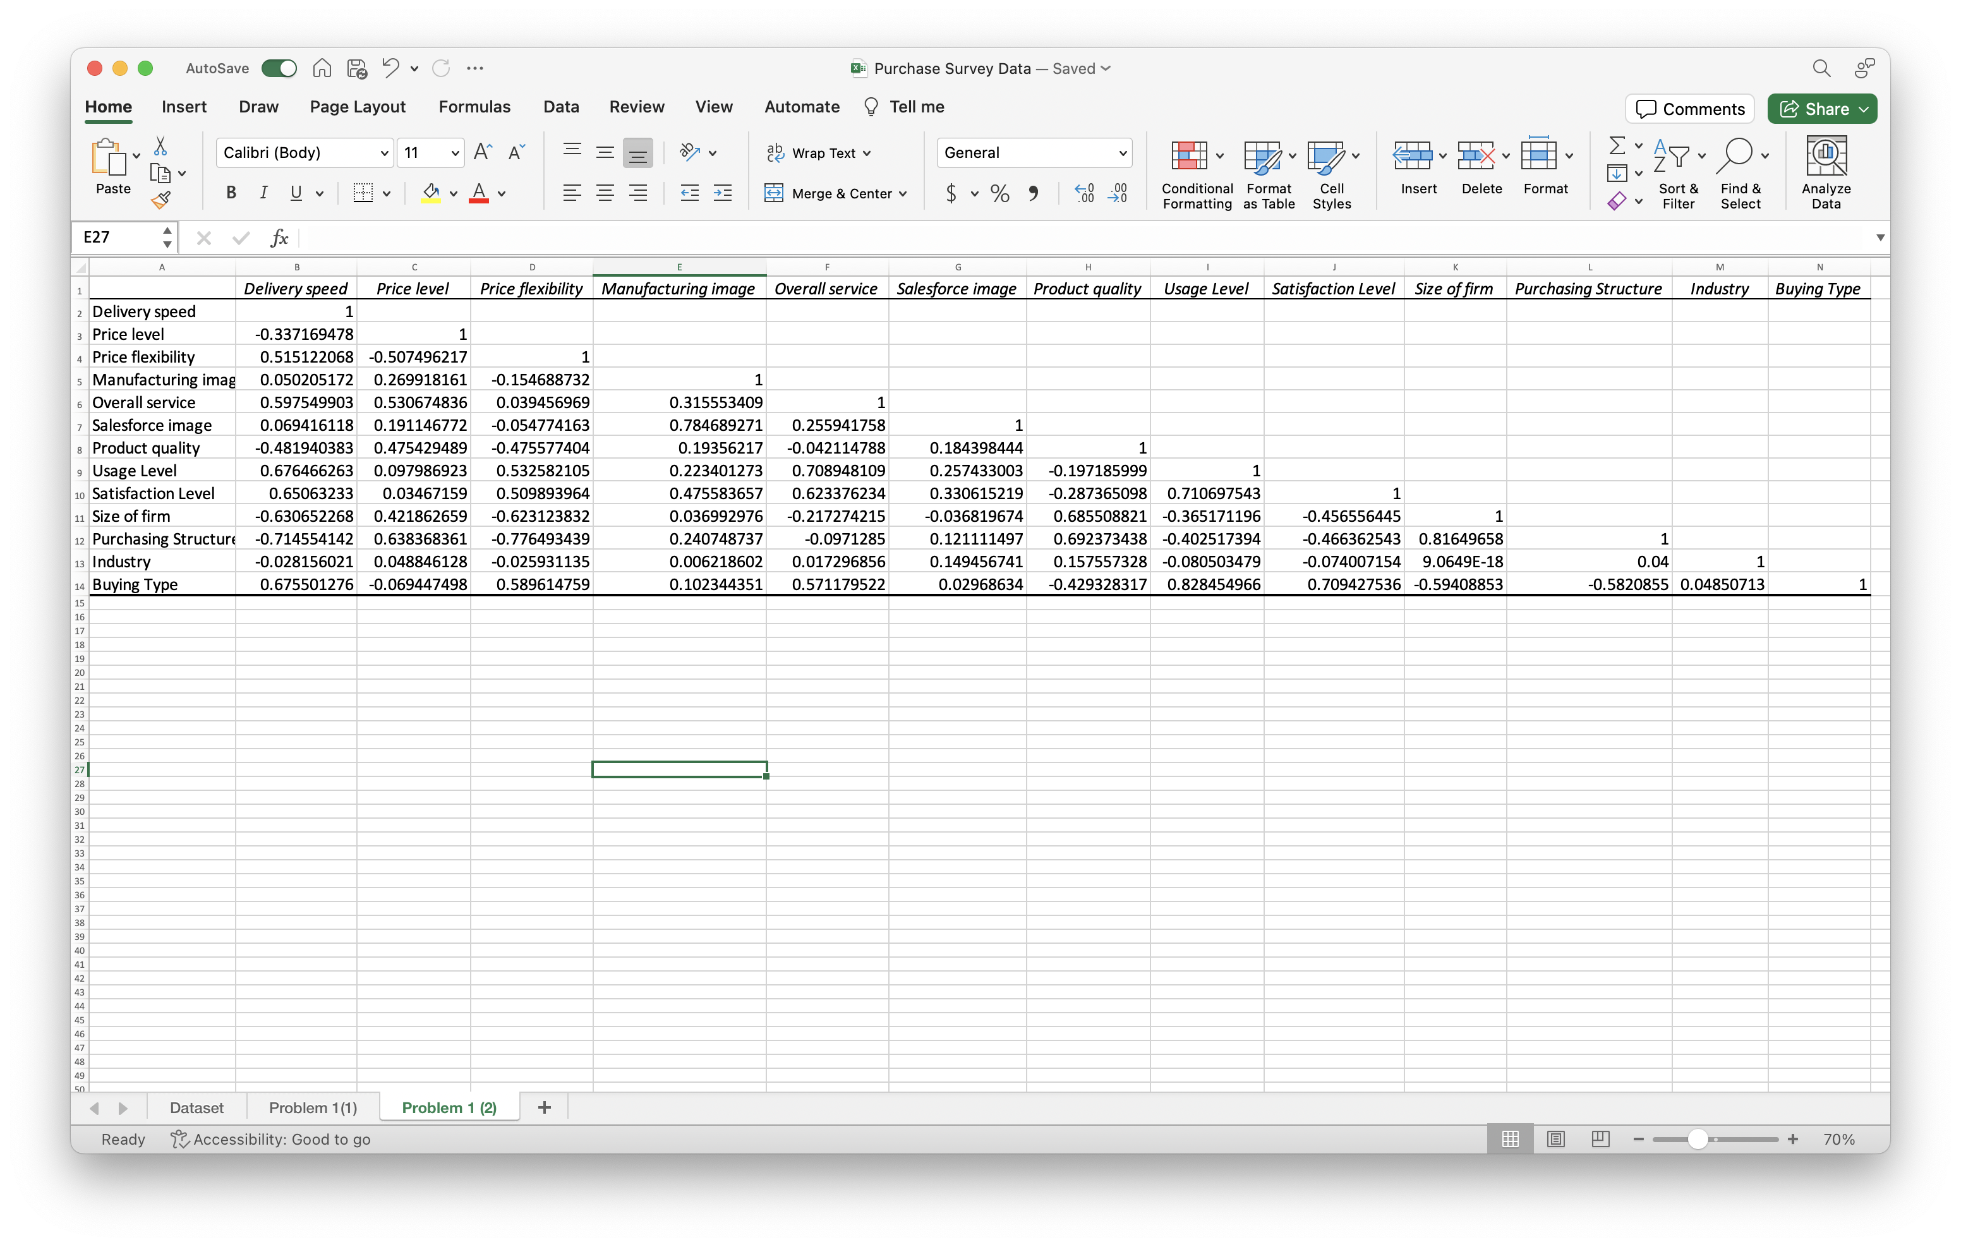

**Problem 2 (10 points):**

Please use the EXCEL file of “Purchase Survey Data”

Please use Tableau to:

1. Create scatter plot for product quality and satisfaction level (5 points).

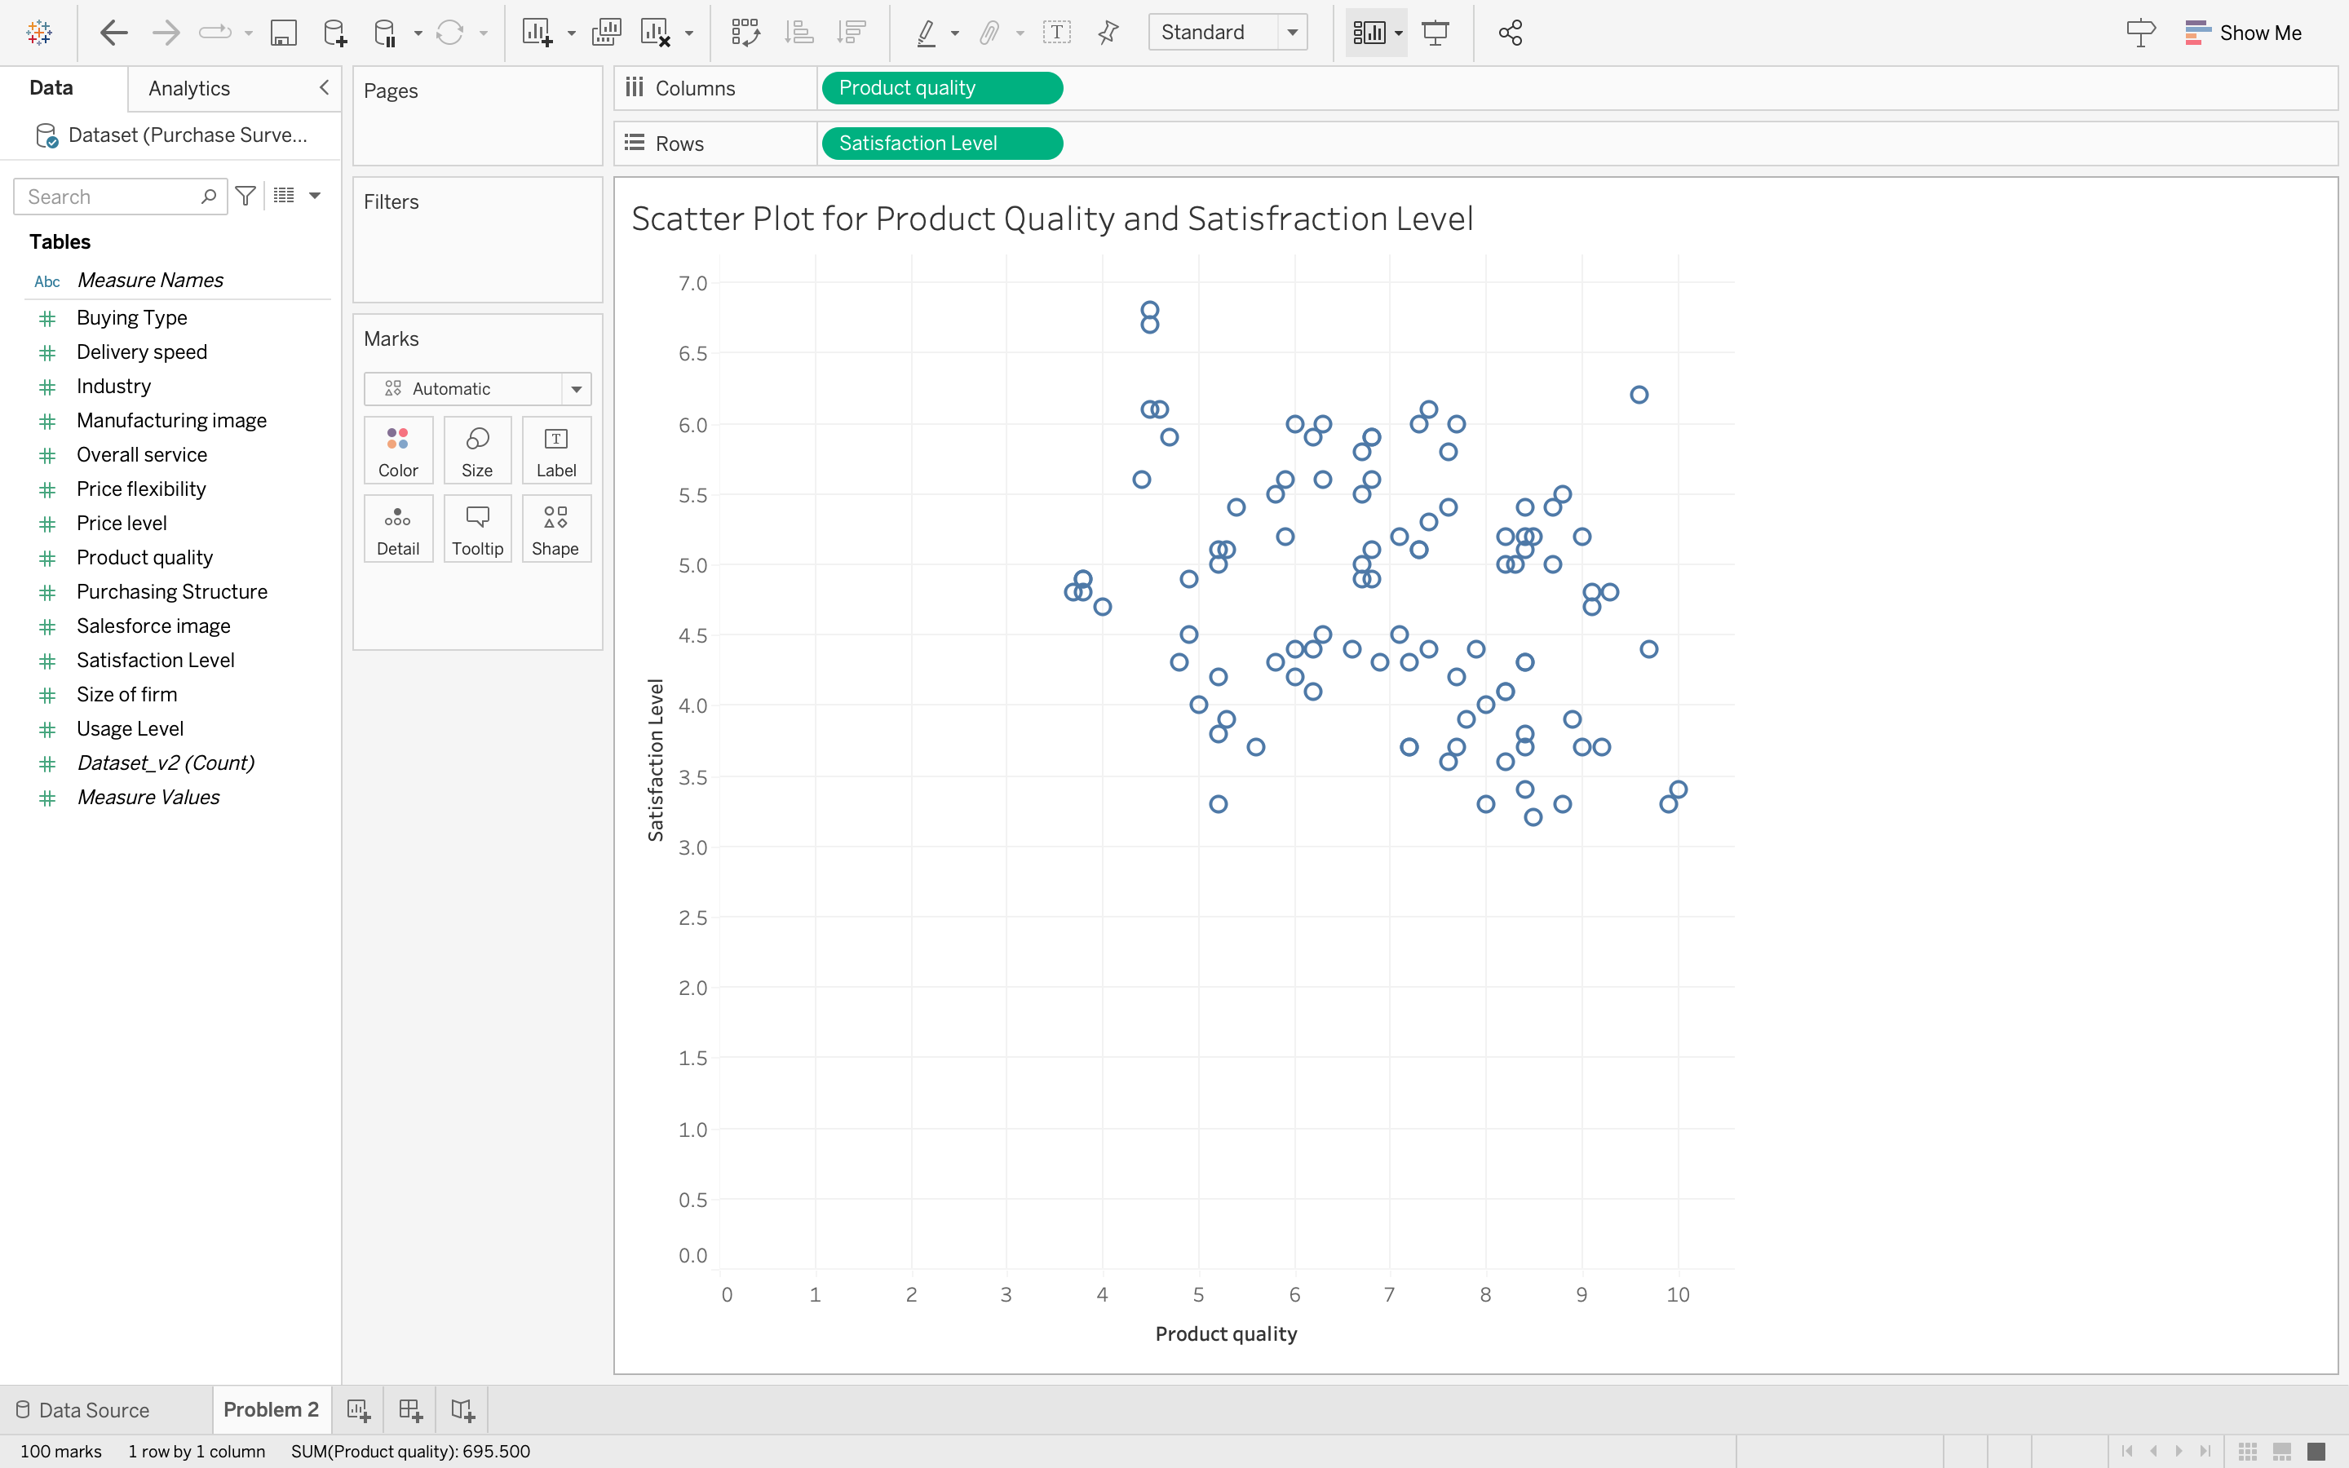

Create summary statistics for product quality and satisfaction level (5 points).

